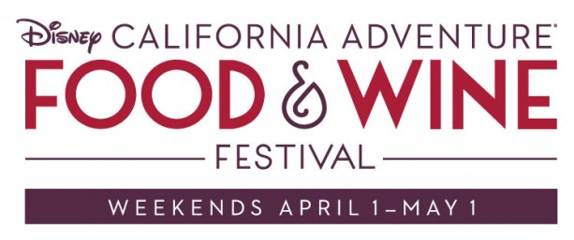
Disney California Adventure Food & Wine Festival Checklist

 | Chilled Ahi Poke with avocado crème and Wakame salad, topped with sesame tuile | LAstyle
 | Pork Belly Bao Taco with pickled vegetables | LAstyle
 | Milk Chocolate Caramel Tart with almond brittle and sea salt | LAstyle
 | Cabernet Flight | The Vineyard
 | Chardonnay Flight | The Vineyard
 | Pinot Noir Flight | The Vineyard
 | Wine and Cuvée by the glass | The Vineyard
 | Zinfandel-Braised Wagyu Beef with creamy polenta and spring pea puree | Wine Country
 | Roasted Yellow Beets and Purple Haze Goat cheese with baby greens, green ver jus, sultanas and cashews | Wine Country
 | Blackberry Tart with rosemary vanilla bean crème fraîche and a Cabernet wine glaze | Wine Country
 | Fried Shrimp Soft Taco with pickled red onion-jalapeno, queso fresco and avocado-lime crèma | ¡Viva Fresca!
 | Anaheim Chile and Roasted Cauliflower Burrito with Jack cheese and avocado-lime crèma | ¡Viva Fresca!
 | Triple Cheese Mac with Smoked Chicken featuring Fontina, Cheddar and Gouda cheeses | Gold Rush
 | Artichoke Chips with Spicy Aioli | Gold Rush
 | Apple Bacon Whoopie Pie with maple cream cheese icing and bacon brittle | Gold Rush
 | Southern California Beer Flight | The Brewhouse
 | Northern California Beer Flight | The Brewhouse
 | Grilled Beef Tenderloin Slider with chimichurri sauce | The Farm
 | Golden Thai Vegetable Curry with jasmine rice | The Farm
 | Meyer Lemon Macaron with blackberry marmalade, Meyer lemon cream and dried blueberry dust | The Farm
 | White Cheddar Ale and Bacon Soup, served in a Boudin sourdough mini-boule | By The Bay
 | Chilled Shrimp and Snow Crab Cocktail | By The Bay
 | Coconut Tapioca layered with fresh mango and lychee boba, topped with green tea micro sponge and mango-couli sesame tuile | By The Bay

